**Discussion of Results**

The experiment yielded graphical results which were consistent with the calculated theoretical values for image distance $d_{i}$ (represented by ‘Q’ in the ray traces) and magnification $M$ (see **Table D1**). The simple ray scenarios (1A, 1B, 2A, 2B) produced results which were within 2% difference of their respective theoretical values, and the more complex scenarios (3, 4) were within 12% difference of their respective theoretical values.

**Table D1**

|  |  |  |  |  |  |  |
| --- | --- | --- | --- | --- | --- | --- |
| $$\#$$ | $$Calculated d_{i}$$ | $$Graphical d_{i}$$ | $$\% Difference$$ | $$Calculated M$$ | $$Graphical M$$ | $$\% Difference$$ |
| 1A | 20cm | 20cm | 0% | -1 | -1 | 0% |
| 1B | 15cm | 15cm | 0% | -0.50 | -0.50 | 0% |
| 2A | 60cm | 61cm | 2% | -2 | -2 | 0% |
| 2B | -20cm | -20cm | 0% | 2 | 2 | 0% |
| 3 | 60cm | 65cm | 9% | 6 | 6.67 | 12% |
| 4 | 12.1cm | 12.2cm | 1% | -0.15 | -0.14 | 8% |

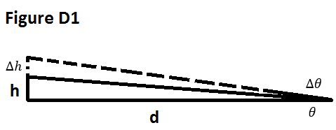Despite using computer software as an aid for ray tracing, the experiment still yielded a fair portion of error. The greatest source of error in the graphical method originated from slight angle variations which propagated into larger offsets over increased distances. As seen in **Figure D1**, a small change in angle $θ$ creates a substantially larger $∆h$ value as d increases. This relation can be expressed as $h=dtanθ$. Scenarios 3 and 4 introduced the greatest potential for error by having large object-to-lens and lens-to-image distances. Furthermore, these same scenarios were each done in two parts, the second part relying upon the results of the first. Any error from the first was carried over and magnified in the second.

The mathematical and graphical methods complement each other. The mathematical provides a precise, theoretical basis. The graphical method provides the visual aid and conceptual understanding which the mathematical method lacks. Because sign convention is key, and often confused in mirror and lens calculations, the graphical method can also serve as a sign convention sanity-check for the mathematical method. Likewise, the mathematical method can serve as a sanity-check for the graphical method.

For better results, the experiment should be done with either very fine-grid graph paper and fine-tipped pens, or with the aid of computer software. Simple software was used to create the ray traces in this experiment (MS paint). Advanced software could help reduce the pixel-sized-inconsistencies at the start and end positions of ray vectors.